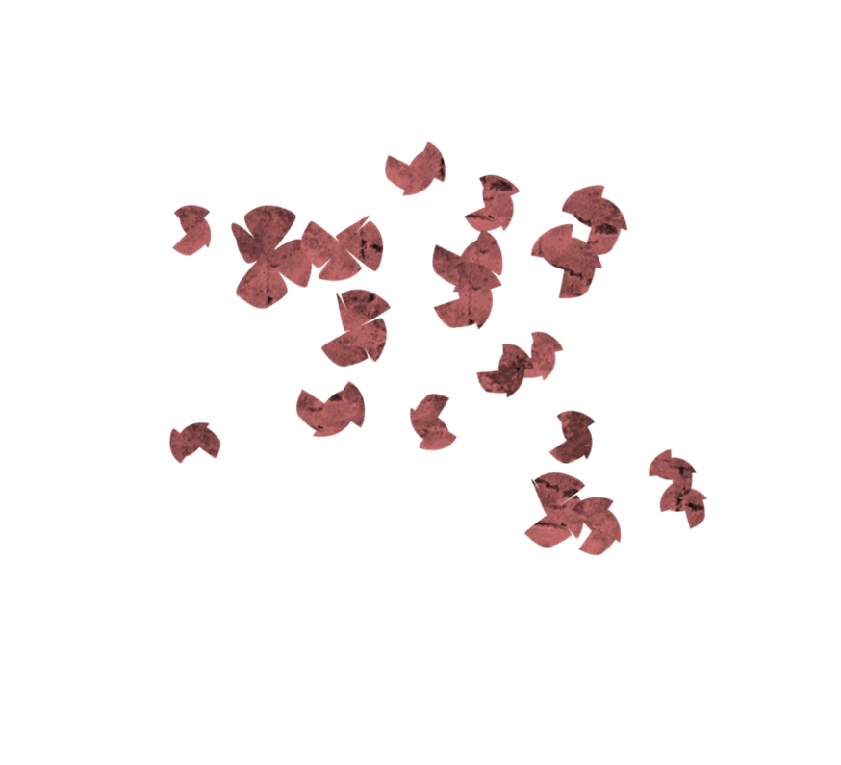

Summer READING CHALLeNGE

Want to expand your reading knowledge?

Here is a simple and fun way to do so! Simply find a book that fits into each of the six weekly categories and tick them off as you go:

* WEEK 1: A book published before you were born
  + …………………………………………
* WEEK 2: A book with a number in the title
  + …………………………………………
* WEEK 3: A book that has been turned into a film
  + …………………………………………
* WEEK 4: A book 6 books in on a book shelf
  + …………………………………………
* WEEK 5: A book that has a mostly red cover
  + …………………………………………
* WEEK 6: A book that is the first in a series
  + …………………………………………

NAME_______________________

FORM_______________________